new green user manual

Table of Contents
Introduction 4
Conventions in this Manual: 4
Section A:Using and Understanding the new green Interface 5
A-1 How to open new green 5
Prepare the files for first use (installation) 5
Start the New Green Program 5
A-2 How to view information in new green 7
A-3 How to print out information from new green 8
A-3.1 Types of reports in new green 8
Section B:Functions in new green 9
Standard buttons used in new green functions: 9
B-1 MAIN form functions 9
B-1.1 SPECIES 9
B-1.2 USES 10
B-1.3 REGION 10
B-1.4 SITEQUIZ 10
Interpreting search results: 11
The SiteQuiz: Step-by-Step 11
B-1.5 EXTENDED OPTIONS 14
B-2 Extended options functions 15
B-2.1 SITES 15
B-2.2 IMAGES 15
B-2.3 REFERENCES 15
Section C:Advanced Users Guide 16
C-1 How to add your own information to new green 16
C-1.1 Editing existing information 16
Text boxes 16
Combo boxes 16
Subforms 16
C-1.2 Adding a new species 17
C-1.3 Adding a new reference 17
C-1.4 Adding a new site 17
C-1.5 Adding a new image 17
C-2 Where data are stored in new green 18
C-3 How to create your own searches (queries) in new green 18
Section D:Glossary 20

Introduction

Welcome to new green, the database of developing green crops!

This user manual will guide you through new green, showing you how to maximise your search for information.

Conventions in this Manual:

- Words indicated in bold italic are contained in the Glossary.

- Words indicated in fixed sys represent information typed into the computer

- New green command buttons are represented as: Button

- Titles of forms are in CAPITAL ITALICS

Using and Understanding the new green Interface

How to open new green
The New green program cannot be run directly from the CD; you must first move all the contents of the CD into your hard drive.

Prepare the files for first use (installation)
Place your CD in the CD drive and close the drive.
Open Windows Explorer.
Locate the X:\NewGreen folder (where X indicates the drive designation of your CD drive).
Drag and drop this X:\NewGreen folder onto the root folder of your C:\ hard drive.

Everything from the CD should now be installed on your hard drive, with the following files in their corresponding folders:

C:\NewGreen\readme.txt
C:\NewGreen\Data\NGdata.mdb
C:\NewGreen\forOffice97\NGcode97.mdb
C:\NewGreen\forOffice2000\NGcode2000.mdb

C:\NewGreen\UserManual\new green user manual.doc

However, the files will all be in a “read-only” state, and this must be changed for each file:
- right-click on the file
- select Properties
- in the General tab of the properties window, un-check the Read-only attribute
- click Apply, then click Close

Start the New Green Program
To start New green, you have to Open the code file designed for the version of Microsoft Access® which is installed on your PC.
If you are using Microsoft Access® v 8 (which comes with Office 97 professional) then open the code file NGcode97.mdb
If you are using Microsoft Access® v 9 (which comes with Office 2000 professional) then open the code file NGcode2000.mdb

New green will open in Microsoft Access. Wait until the loading is complete. Your screen should look like Figure A-1.2. new green is now open and ready for use.
Figure A-1-1: A successful start-up – The MAIN form of new green
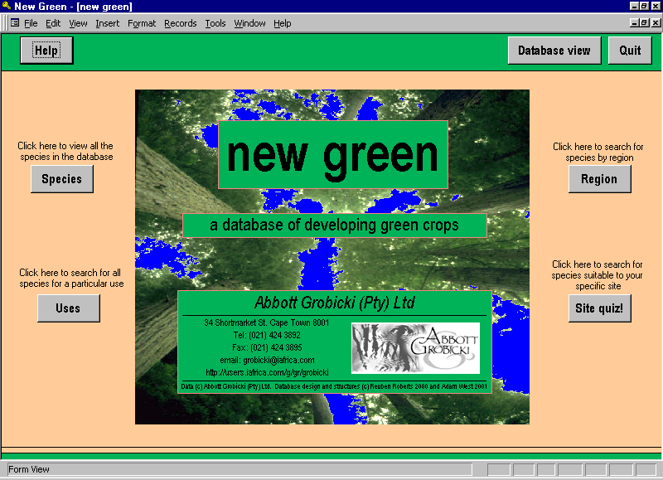

How to view information in new green
All the data in new green are stored in sets of inter-linked spreadsheet tables. You, the user, primarily have access to these data through the graphical interface. This graphical interface, which opens automatically, consists of a series of pages called “forms” and simply provides a clear way of viewing and searching the data.

On every Form, there are several command buttons. It is strongly recommended that users use these command buttons to navigate between the forms of the graphical interface rather than opening forms from the database window and closing forms using the close window button (). The command buttons have a functionality (e.g. updating records, checking indices, closing relevant forms, passing parameters etc.) that generalised menu buttons do not have.

New green has several pre-programmed functions to aid you in your search for useful information. These functions are all accessed by clicking command buttons on the MAIN form of the graphical interface. These functions are discussed in detail in “SECTION B: Functions in new green”.

There is Help available on most forms which explains the outcome of clicking each command button on the form.

Figure A-2-2: The MAIN form from the graphical interface showing Command Buttons which should be used to navigate through new green
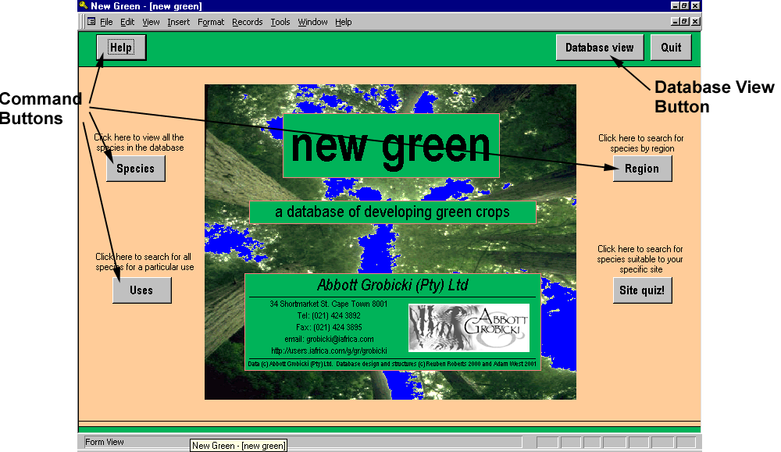

Should you wish to view the tables directly, or modify aspects of the database, you can click Database view on the MAIN form. The database window will then open and the graphical interface will close. NOTE: This is NOT recommended for users not familiar with MS Access! Modification of objects in the database could corrupt the database! For experienced users who wish to use the database window, please refer to “SECTION C: Advanced Users Guide”.

How to print out information from new green
In database terminology, any printed information generated by the database is called a “report”.

When the user creates a report in new green by clicking Print, a report preview window opens. In this window the user can preview the report created before printing it out. To print the report from this window, click the print button on the toolbar () or select “Print” from the File Menu. To return to the new green graphical interface, the user must click the close button on the tool bar ().

Types of reports in new green
There are two main types of reports that can be generated in new green, information reports and species-list reports.

Information reports can be generated from the SPECIES form and the SITES form. In these reports, all the information pertaining to the selected species or site is printed out in a single report.

Species-list reports can be generated from the pre-programmed functions (see Section B for more details). These reports provide a list of suitable species based on information the user supplied or selected. These reports are primarily intended to be used as reference material for consulting the SPECIES form.

Functions in new green
New green has several pre-programmed functions to aid you in your search for useful information. These functions are all accessed by clicking command buttons on the MAIN form, or EXTENDED OPTIONS form of the graphical interface. We will discuss each of these functions in turn.

Standard buttons used in new green functions:
All functions use the following standard buttons.
Submit – performs the search based on the criteria entered by the user
Clear – clears all the search results and the criteria on that form
Back – steps back to the previous form
Print list – generates a report preview of the search results or species information that can be printed out.
Print – on the SPECIES and SITES form, this generates a report preview of the species information
View details – shows all the details of the searched species in a form similar to the SPECIES form
Only in the SiteQuiz:
Use ONLY these criteria – acts the same as Submit. It performs the search for species based on the criteria entered on that form only (i.e. no previous criteria are included).
Use ALL search criteria – acts the same as Submit. It performs the search for species based on the all criteria entered in the SiteQuiz so far.
Continue – moves to the next form in the SiteQuiz.

MAIN form functions
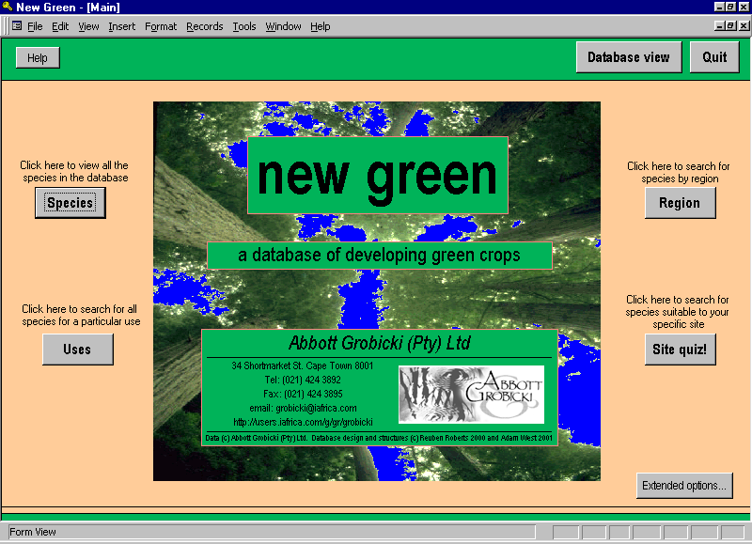

SPECIES
This function opens the SPECIES form. In this form the user can select any species in the database and view all of the information on that species. In order to see any information, the user must click on a species in the “Select a species” drop-down box.
Figure B-1-3: Clicking on a species in the “Select a species” drop-down box
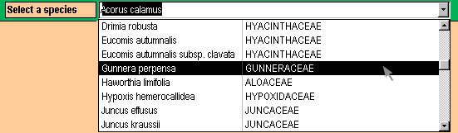

Once a species is selected, the information for that species becomes visible. The information is contained on several pages accessed by Tab Controls found just below the “Select a species” drop-down box. By clicking on the tab controls, the user can view the information contained on each of these pages.

In order to print out all the information for the selected species, click Print.

USES
This opens the CUSTOM SELECTION OF USES form. On this form the user can select any number of plant uses from the list provided. Once a selection has been made, clicking Submit creates a species list of plants corresponding to those uses. This list can then be printed out for reference (click Print ), or the details of the plants viewed in the SPECIES Form (click Viewdetails ).

Tips for selecting uses: Click once on a use to select it. Selection is indicated by the item being highlighted. To deselect a use, click the item again, the highlighting will disappear. To clear all selections click Clear.

There are also some links to informative documents at the bottom of the form. Clicking these command buttons will open the relevant documents in Microsoft Word, where they can be printed out.

REGION
This opens the CUSTOM SELECTION OF REGION form. On this form the user can select any number regions in South Africa from the list provided. Once a selection has been made, clicking Submit creates a species list of plants corresponding to those regions. This list can then be printed out for reference (click Print ), or the details of the plants can be viewed in the SPECIES form (click Viewdetails ).

Tips for selecting regions: Click once on a region to select it. Selection is indicated by the item being highlighted. To deselect a region, click the item again, the highlighting will disappear. To clear all selections click Clear.

SITEQUIZ
This opens the SiteQuiz Wizard, starting with the SITE QUIZ: CLIMATIC LIMITS form.

The SiteQuiz Wizard is designed to help the user find suitable species for his/her site. The SiteQuiz Wizard consists of a series of forms that asks the user for information about his/her site. Each time new information is submitted by the user it is added to the previous search criteria and the search is narrowed. At every stage of the SiteQuiz, the user can see how many species in the database are suitable for his/her site and may choose to view or print out those species. Please note: careful interpretation of the SiteQuiz search results is required (see “Interpreting search results” below).

Interpreting search results:
For all of the searches in the SiteQuiz, any null values have been included into the search parameters. Including null values into the search parameters gives the user much more flexibility in viewing potentially suitable species. Species that might otherwise have been excluded due to a null value in a key criterion, are now returned. These “null-searched” species are easily identifiable as they have blanks in the specific criteria for which they have no information. It is up to the user to determine whether up not these “null-searched” species are suitable for the site in mind.

For example - The user enters values for rainfall and temperature limits on the first SiteQuiz form:
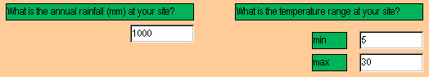
On clicking Submit, species are returned by two pathways:
- all species that fall within the climatic limits specified above are returned.
- any species in the database for which rainfall and temperature limits have not been entered are also returned.

The SiteQuiz: Step-by-Step

Tips for successful searching:
- When asked for values, only type in numbers, units are not required (i.e. if your average annual Rainfall is 800 mm, enter 800, not 800mm, in the rainfall box)
- You do not have to enter information for all of the criteria. If you leave a field blank, the SiteQuiz will simply ignore that criterion.

SITE QUIZ: CLIMATIC LIMITS

Overview
This form asks the user to enter the average annual rainfall (in mm) and temperature limits (in °C) for the site in mind. The user types in the relevant information and the clicks Submit to view the search results. The user can generate a report of the search results (click Print list ) or can view all the details of searched species listed (click View details ). To continue to the next form in the SiteQuiz, click Continue. The search criteria will be passed on to the SITE QUIZ: SOIL INFORMATION form and will be shown at the bottom of this form. If the user wishes to skip this form in the SiteQuiz he/she can click Continue without entering any criteria.

Tips for successful searching:
- only type in numbers, units are not required (i.e. if your average annual Rainfall is 800 mm, enter 800, not 800mm, in the rainfall box)
- you do not have to enter information for all of the criteria. If you leave a field blank, the SiteQuiz will simply ignore that criterion
- if you click Submit without entering any criteria, all the species in the database will be returned
- Note: the user-defined criteria are used to exclude species that are not suitable from the search results. Thus, when entering climatic information, the user should be wary of entering extreme recorded values. Rather, annual or 5-year averages should be used so as to include as many potential species as possible in the search results

Specific search logic
On this form, species are returned that have:
- a minimum rainfall requirement less than the user-defined rainfall value AND
- a maximum rainfall requirement greater than the user-defined rainfall value AND
- a minimum tolerated temperature less than the user-defined minimum site temperature AND
- a maximum tolerated temperature greater than the user-defined maximum site temperature AND

Algorithm = ([RainfallMin] <= User(Rainfall) OR Is Null)
AND ([RainfallMax] >= User(Rainfall) OR Is Null)
AND ([TempMin] <= User(minimum Temperature) OR Is Null)
AND ([TempMax] >= User(maximum Temperature) OR Is Null)

Note: for all algorithms the variable “User(description)” is the user-defined value or selection entered on the form.

Site Quiz: Soil Information

Overview
This is the second form in the SiteQuiz. On this form, the user is asked to enter the average soil pH and all the soil textures that are found in the site in mind. The procedure is exactly the same for this form as for the SITE QUIZ: CLIMATIC INFORMATION form except Submit has been replaced by Use ONLY these criteria and Use ALL search criteria.
Use ONLY these criteria – performs the search for species based on the criteria entered on that form only (i.e. no Climatic Information criteria are included). Thus, the user is able to generate a list based on the soil information alone.
Use ALL search criteria –performs the search for species based on the Climatic Information and the Soil Information.
To skip this form of the SiteQuiz, simply click Continue.

Tips for successful searching:
- you do not have to enter information for all of the criteria. If you leave a field blank, the SiteQuiz will simply ignore that criterion
- if you click Use ALL search criteria without entering any criteria, all the species from the previous Climatic Information search will be returned

Specific search logic
If you click Use ONLY these criteria species are returned that have:
- a minimum tolerated soil pH less than the user-defined minimum pH AND
- a maximum tolerated soil pH greater than the user-defined maximum pH AND
- soil textures in common with the user-defined soil textures

Algorithm = ([Soil pH Min] <= User(Soil pH) OR Is Null)
AND ([Soil pH Max] >= User(Soil pH) OR Is Null)
AND ([Soil textures] = User(Textures) OR [All Soil textures] Is Null)

If you click Use ALL search criteria species are returned that have:
- been returned by the previous search AND
- a minimum tolerated soil pH less than the user-defined minimum pH AND
- a maximum tolerated soil pH greater than the user-defined maximum pH AND
- soil textures in common with the user-defined soil textures

Site Quiz: WATER AVAILABILITY

Overview
This is the third form in the SiteQuiz. On this form, the user is asked to select the type/s of habitat in terms of water availability found in the site in mind. The water availability criterion is used to eliminate species from the search results that have higher water requirements than exist on the site.
The procedure for this form is exactly the same as for the SITE QUIZ: SOIL INFORMATION form. To skip this form of the SiteQuiz, simply click Continue.

Tips for successful searching:
- it is important to select all the types of water availability that occur on your site, and not just the predominant one.
- if you click Use ALL search criteria without entering any criteria, all the species from the previous two searches will be returned

Specific search logic
If you click Use ONLY these criteria species are returned that have:
- water requirements in common with the user-defined water availability

Algorithm = ([Water Requirements] = User(Water Requirements) OR Is Null)

If you click Use ALL search criteria species are returned that have:
- been returned by the previous searches AND
- water requirements in common with the user-defined water availability

Site Quiz: SITE MODIFICATIONS

Overview
This is the last form in the SiteQuiz. On this form, the user is asked:
Are you able to modify your site through excavation or the construction of dams?
Are you able to irrigate you site with ground water, river water or runoff water?
If the answer to either of these questions is “Yes” then the user should click Yes next to the relevant question. The user can then enter information in the boxes that become visible.

Site Modifications:
If the user clicks Yes, the Modifications box appears. This box is similar to the Water Availability box on the previous form. The user should select the options that will reflect the new situation on the site, after the modifications. Note: if Use ALL search criteria is now clicked, the selections in the Modification box will replace the selections of the Water Availability box.

Irrigation:
If the user clicks Yes, the Irrigation box appears. The user should enter the amount of water that can be added to the site, exclusive of rainfall. The amount of irrigated water is then added to the amount of rainfall entered on the first SiteQuiz form. This new “Total water” amount is then used to search the database in the same manner Rainfall was used in the first site.

Tips for successful searching:
- it is important to select all the types of water availability that will occur on your site. The criteria selected in this box replace those selected in the SITE QUIZ: WATER AVAILABILITY form
- for the irrigation input: only type in numbers, units are not required (i.e. if your irrigation input is 1200 mm, enter 1200, not 1200mm, in the Irrigation box)
- if you click Use ALL search criteria without entering any criteria, all the species from the previous two searches will be returned

Specific search logic
If you click Use ONLY these criteria species are returned that have:
- water requirements in common with the user-defined site modifications AND
- a minimum rainfall requirement less than the new total water value AND
- a maximum rainfall requirement greater than the new total water AND

Algorithm = ([RainfallMin] <= [User(Rainfall) + User(Irrigation)] OR Is Null)
AND ([RainfallMax] >= [User(Rainfall) + User(Irrigation)]OR Is Null)
AND ([Water Requirements] = User(Modifications) OR Is Null)

If you click Use ALL search criteria species are returned that have:
- a minimum rainfall requirement less than the new total water value AND
- a maximum rainfall requirement greater than the new total water AND
- been returned by the temperature criteria of the Climatic Information search AND
- been returned by the Soil Information search AND
- water requirements in common with the user-defined site modifications

Algorithm = ([RainfallMin] <= [User(Rainfall) + User(Irrigation)] OR Is Null)
AND ([RainfallMax] >= [User(Rainfall) + User(Irrigation)]OR Is Null)
AND ([TempMin] <= User(minimum Temperature) OR Is Null)
AND ([TempMax] >= User(maximum Temperature) OR Is Null)
AND ([Soil pH Min] <= User(Soil pH) OR Is Null)
AND ([Soil pH Max] >= User(Soil pH) OR Is Null)
AND ([Soil textures] = User(Textures) OR [All Soil textures] Is Null)
AND ([Water Requirements] = User(Modifications) OR Is Null)

SITE QUIZ: CONCLUSION
You have finished the SiteQuiz. Click Return to Main Menu to end the SiteQuiz and return to the MAIN form.

EXTENDED OPTIONS
This opens the EXTENDED OPTIONS form, which looks similar to the MAIN form, and operates in exactly the same way. A detailed description of these functions is provided in “Section B-2: Extended options functions”.

Extended options functions
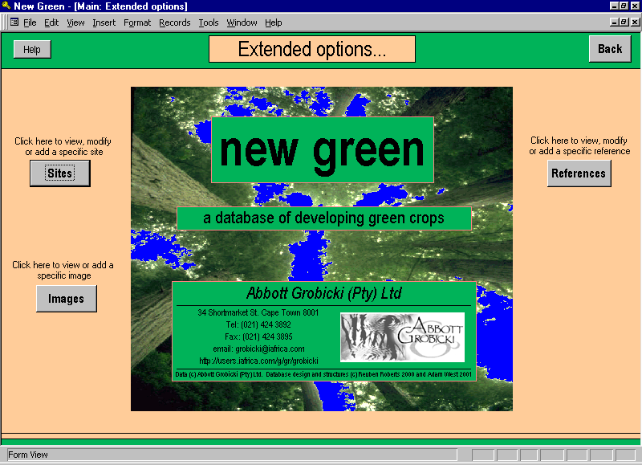

SITES
This opens the SITES form. On this form the user can view information pertaining to specific site locations. The sites are linked to the species that occur in that site and to any relevant references. These can be viewed by using the tab controls positioned below the “Select a Site” drop-down box. To view the details of either a linked species or reference, highlight the relevant item and click View. Either the SPECIES form or the REFERENCES form will open with the relevant details. To return to the SITES form click Back.
The user can also add new sites to the new green database (discussed in “SECTION C: Advanced users Guide”).

IMAGES
This opens the IMAGES form. On this form the user can view images of various species that are stored in the new green database. To view the details of the species concerned, highlight that species in the “Species for Image” window and click View. The SPECIES form will open with the details of that species. To return to the IMAGES form click Back.
The user can also add new images (discussed in “SECTION C: Advanced users Guide”).

REFERENCES
This opens the REFERENCES form. On this form the user can view information pertaining to specific references cited in the new green database. These references are linked to the relevant species. To view the details of a referenced species, highlight that species and click View. The SPECIES form will open with the details of that species. To return to the REFERENCES form click Back.
The user can also add new references (discussed in “SECTION C: Advanced users Guide”).

Advanced Users Guide

How to add your own information to new green
new green is designed to be an expandable database. As new information becomes available so it can be entered and the database can be kept current. Below are discussed the main ways of updating existing information or adding new information.

Editing existing information
All the forms of the new green graphical interface are editable. This means the user can permanently alter the stored data in the underlying tables of new green by editing specific data on a form. For example, if the family name of a particular species changed, the user could call up that species on the SPECIES form, select the family name field and type it to the new name. This new name would be permanently stored in the database and the old name lost. For this reason, the user must exercise caution not to alter information by accident on any forms.

Information can be edited in different controls in new green. These controls behave in slightly different manner and are discussed below:

Text boxes
Information can be edited in a text box as one would edit any text document. Click on the text at the desired location and perform the edit. A scroll bar on the right-hand side of the text box can be used to scroll down the document.

Figure C-1-4: An example of text box


Combo boxes
Combo boxes are a combination of a list box and a text box. In a combo box the user can either type in a value or select one from the list. It is recommended that a value be selected from the list. This is so that data can remain comparable and can be more easilycategorised. However, the user can enter a new value if there is nothing suitable on the list. To do this, the user can type in a value and press ENTER. A message box will appear notifying the user that this item is not on the list. The user should choose to add it to the list.
Figure C-1-5: An example of a combo box
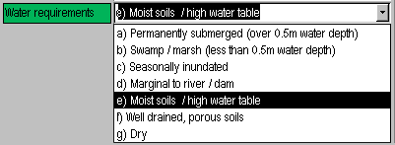

Subforms
Subforms are forms within forms. They are used to capture multiple entry data. For example: SA Distribution in the SPECIES form. As a species may occur in more than one area, the user must be able to select more than one region per species. Subforms allow this by replicating a control the moment it is filled in. The new, empty control appears directly below the old one, and can then be assigned a different value. A scroll-bar appears on the right-hand side to allow the user to scroll down to the new control.

Subforms use textboxes and combo boxes and they can be edited as described above. Deleting information from a subform is achieved by highlighting the item to be deleted and clicking Del.
Figure C-1-6: An example of a subform. Note the new blank fields below the ones containing data
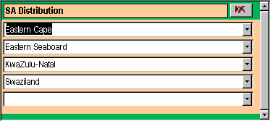

Adding a new species
On the SPECIES form, click Add. A blank form will be opened and the user can then fill in all the details for that new species in the manner described in “Editing existing information” above.

Adding a new reference
On the REFERENCE form click Add. A blank form will be opened and the user can then fill in all the details for that new reference in the manner described in “Editing existing information” above.

On the SPECIES or SITES form click the “References” tab control. Type in the name of the author, if the database does not recognise this author, a message box will appear asking you if you want to add this author to the list of references. On clicking yes, a subform will open that allows the user to type in the details of his new reference. These details will be added to the new green reference table.

Adding a new site
On the SITES form click Add. A blank form will be opened and the user can then fill in all the details for that new site in the manner described in “Editing existing information” above.

On the SPECIES form, the user can add a new site name by clicking the “Sites” tab control and typing a new name into the “Site” combo box. However, the user must then go to the SITES form to add the other details of the new site.

Adding a new image
Images must be in Bitmap format.

On the IMAGES form click Add. A blank form will be opened and the user can then fill in all the details for that new image in the manner described in “Editing existing information” above. The image can then be added by clicking Insert or link Image file. A window will open that asks the user to specify the location of the image.

Where data are stored in new green
All the data in new green are stored in sets of inter-linked tables. A list of all the tables can be viewed by clicking the “Tables” tab control in the database view. The relationships between these tables can be viewed by clicking “Tools” and then “Relationships” on the MS Access menu. It is extremely important that these relationships are not destroyed or disrupted. It is these relationships that allow the new green database to function.

For all the tables in new green, the naming protocol is as follows: The first letter of the name describes the type of object (i.e. Table). The next word describes the object’s content (i.e. “Species” information, “Site” information, “aList” of names etc.). A second word attached to the name (optional) refers to the subset of information contained in that particular object. These words are all separated by an underscore (“_”).
e.g. | T_aList_Biome | a list of all Biomes used in the database
 | T_Species | the table storing the basic species information
 | T_Species_Geology | the table storing the Geology component of the species information

How to create your own searches (queries) in new green
It may be useful for the user to create his/her own queries in new green to search for specific information. Queries can be created as follows:
- Click Database view on the MAIN form, click “Query” on the database window and then “New”.
- Select “Design View” and click “Ok”. The query design window comes up and asks the user to select the table/s on which the query should be based.
- Select the relevant table and click “Add”.
- If the user had selected T_Species and T_Species_Biome, the screen should now look something like the figure below:
Figure C-3-7: Query design grid
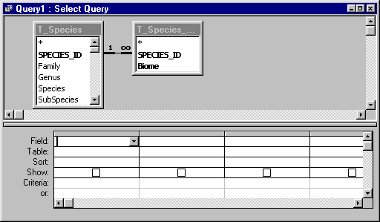
- The next step is to decide what fields are to be involved in the query. Fields can be involved in 2 ways: those that are displayed as columns in the resulting table, or those in which certain criteria have to be met.
- Double-clicking on a field adds it to the query. Fields should be added in the sequence that the user wishes to see in the results table. In this example SPECIES_ID, Genus and Species are added from the T_Species table, and Biome is added from the T_Species_Biome table.
- Each field is added with a tick in the “Show:” check box. This indicates that the field will be displayed in the table. In this example we do not want SPECIES_ID to appear in the results table, so its Show check box is cleared.
- The results can be sorted by one or more fields, by click “Sort:” and selecting Ascending or Descending. In this example, the query is sorted by Genus in ascending order and by Biome in descending order.
- The search criteria are entered in the appropriate column/s of the “Criteria” row. In this example we only wish to see species that occur in the “Fynbos” biome.
Syntax for the search criteria:
- if text in the field has only a few alternatives then you can enter the alternative you want in inverted commas
- if the search text might be embedded in other text, such as “grows in wet places”, then the text must be surrounded by the any text indicator (*) and the concatenation symbol (&). Thus to search for “wet” in the above phase, your criteria would look be: Like “*” & “wet” & “*”
- numeric operators can also be included. Thus, searching for plants less than 2m tall would have the following criteria in the height column: >= 2 (or less than or equal to 2)
- You query design should look like the figure below. To test your query, click the datasheet view button () on the standard toolbar. To go back to the design view click the design view button ().
Figure C-3-8: Final query design
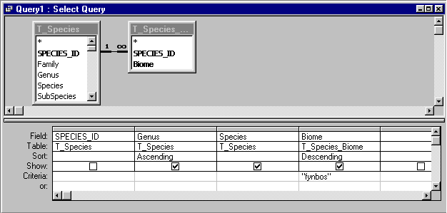

Glossary

Command Buttons | buttons located on forms that perform commands when clicked. Navigating through the new green interface should be done by using command buttons. All of the pre-programmed functions can be accessed by using command buttons. Command buttons are identified by …
Controls | All the information on a form or report is contained in controls. Controls are objects on a form or report that display data, perform actions, or decorate the form or report. For example, you can use a text box on a form or report to display data or a command button on a form to perform an action.
Database window | The MS Access window that gives direct access to the Tables, Queries, Forms, Reports, Macros and Modules of the new green database.
Drop-down box | the associated with combo boxes. Clicking on this symbol opens a list box below the control.
Fields | Categories of information in the database. Each species entered in the new green database, has numerous fields attached to it. Examples of these fields are minimum rainfall, maximum temperature, water requirements etc.
Forms | are a graphical way of displaying data more conveniently. Forms are used to present filtered and sorted data from one or more tables in a clear and simple manner.
Graphical interface | the collection of forms that allows the user to view and search the new green database in a visually convenient manner. Without this graphical interface, the user would have to search and filter the database manually before any useful information could be extracted.
Null | refers to the absence of any data. When a field is left blank, with no information entered, that field is said to contain a “null” value.
Null-searched species | refers to a species returned by a search that was selected on the basis of not having a value in the specific criterion that was searched.  e.g. Species X tolerates a minimum rainfall of 550mm per annum. The minimum rainfall limit for Species Y is not known, or has not been entered into the new green database. If a search is conducted for all species that can tolerate a minimum rainfall of 600mm per annum, both Species X and Species Y will be returned in the search results, Species Y being a “null-searched species”.
Pre-programmed Functions | To simply the search for information, new green has numerous pre-programmed functions that are available to the user. These functions are all run by clicking command buttons on the graphical interface. These functions typically ask the user to select or enter some information before searching the database for relevant species.
Queries | are the MS Access term for “Searches”. You use queries to view, change, and analyse data in different ways. You can also use them as the source of records for forms and reports.
Reports | are the way data is presented in a printed format. Reports operate in a similar manner to forms, presenting filtered and sorted data from one or more tables in a clear and simple manner, and can be printed out.
Parameters | are values that can be passed to a search or query. Parameters allow the same search to be run for different items simply by changing the parameters and without having to change the structure of the search.
Tab Controls | are buttons on a form that toggle between different sets of information when clicked.
Tables | contain all of the data in a database
User-defined | refers to anything that has been entered or selected by the user. This differs from “pre-defined”, where the value has been pre-programmed into the new green database.

